**Discussion: Introduction to Tables (Lab 02)**

Tables are a fundamental way of representing data sets. A table can be viewed in two ways:

* a sequence of named columns that each describe a single attribute of all entries in a data set, or
* a sequence of rows that each contain all information for each attribute about a single entry in a data set.

**1. Ready, Willing and Table**

Let’s look at an example table called staff

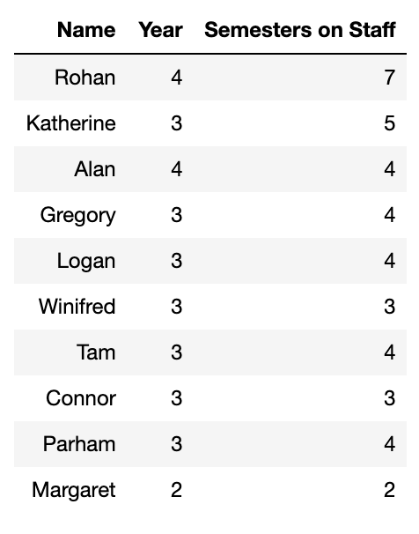

The table has 10 rows, each corresponding to one member of Data 8 Staff. Each row has three attributes, the staff member’s name, year, and how many semesters they have been on staff.Using just the information from the staff table, do we have enough information to generate the following by hand? If not, what additional information do you need?

(You don’t need to worry about how you’d do it in Python.)

**A.** True / False **B.** True / False

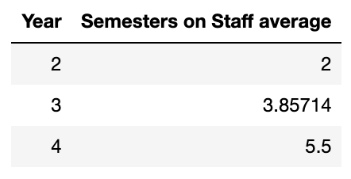 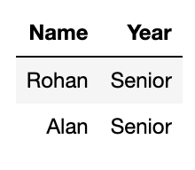

**C.** True / False

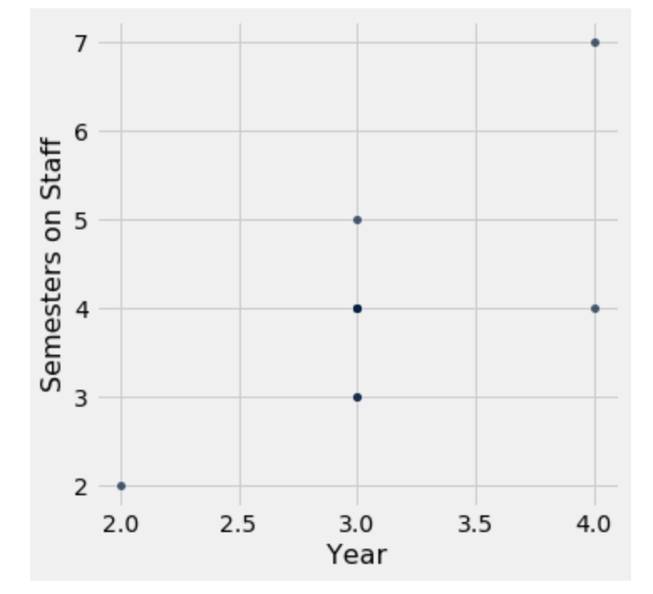

**2. Casuality, Coworkers and Coffee**

Divyesh collected the following information about his coworkers’ methods of getting to work and their coffee consumption.

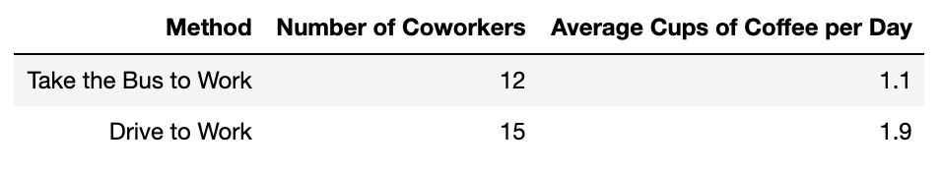

**A.** Divyesh is trying to compute the total yearly difference between the cups of coffee that his driving coworkers drink and the cups of coffee his coworkers who bus drink. He will do all of this in a single cell. Identify the errors in the following cell and correct them. *Make sure that the code cell outputs a single positive number.*

number_cups_day_difference = (12(1.1 - 15(1.9)))

number_cups_week_difference = number_cups_difference * 7

yearly cups = number_cups_week_difference * 52

**B.** Is there a relationship between transportation method and coffee consumption—an association, a causal relationship or something else? Why?